Project Design Phase-II Technology Stack (Architecture & Stack)

|  |  |
| --- | --- |
| Date | 16 October 2022 |
| Team ID | PNT2022TMID28213 |
| Project Name | Project - Job/Skill Recommender Application |
| Maximum Marks | 4 Marks |

# Technical Architecture:

The Deliverable shall include the architectural diagram as below and the information as per the table1 & table 2

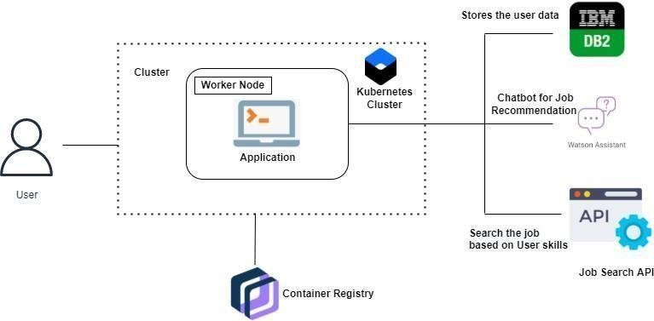

# Table-1 : Components & Technologies:

|  |  |  |  |
| --- | --- | --- | --- |
| **S.No** | **Component** | **Description** | **Technology** |
| 1. | User Interface | The user can interacts with our application with the  help of chatbot, etc. | HTML, CSS, JavaScript / AngularJs /  React Js etc. |
| 2. | Application Logic-1 | The User can login with application, by previously  he should register in our web app. | Javascript |
| 3. | Application Logic-2 | They can also register with the help of a chatbot. | IBM Watson Assistant |
| 4. | Cloud Database | The user data will be stored and retrieved with the  help of this database. | IBM DB2, IBM Cloudant etc. |
| 5. | File Storage | The user documents like photos, resumes and  much more will be stored in cloud bucket, etc., | IBM Block Storage or Other Storage  Service or Local Filesystem |
| 6. | External API | With the help of API, the user can search the job  based on their Skillset. | IBM API, etc. |
| 7. | Infrastructure (Server / Cloud) | Application Deployment on Local System / Cloud | Local, Cloud Foundry, Kubernetes, etc. |

**Table-2: Application Characteristics:**

|  |  |  |
| --- | --- | --- |
| **S.No** | **Characteristics** | **Description** |
| 1. | Is it Scalable? | It follows highly scalable technologies that allows application to handle increase in large user data's workload and perform any operation without any problem. |
| 2. | Is it Modifiable? | It is highly Modifiable and Maintenance requires low cost, compared to other applications. |
| 3. | Is the System Robust? | It does not disturb the performance of the computer by not affecting the operating system. It  works in minimal hardware systems. |